Lab#11 Design Header & Navigation bar with dropdown using Tailwind CSS.

TAGS USED | DESCRIPTION
<!DOCTYPE html> | Declares the document as an HTML5 document.
<html> | Root element of the HTML document.
<head> | Contains metadata and information about the HTML document.
<title> | Specifies the title shown in the browser tab.
<script> | Links the Tailwind CSS CDN to the HTML document.
<body> | Contains all visible content of the webpage.
<header> | Defines the header section of the webpage.
<div> | Groups elements and uses Flexbox to align items.
<h1> | Defines the main heading or store logo, “niki's store”.
<nav> | Defines the navigation section of the webpage.
<a> | Defines hyperlinks such as Home, About, Contact, Laptop, Mobile, and Shoes.
<button> | Creates the Products dropdown button.
<div class="relative group"> | Creates a parent container for the dropdown menu.
<div class="hidden group-hover:block"> | Hides the dropdown menu until the user hovers over it.
class="bg-orange-600" | Sets the header background color to orange.
class="text-white" | Sets the text color to white.
class="p-4" | Adds padding around the header content.
class="flex justify-between items-center" | Arranges the logo and navigation horizontally with space between them and vertically centers them.
class="text-2xl font-bold" | Makes the store logo larger and bold.
class="flex gap-6" | Arranges navigation links horizontally with spacing between them.
class="hover:text-purple-800" | Changes the text color to purple when the user hovers over a link or button.
class="absolute bg-white text-black p-2 w-32" | Positions and styles the dropdown menu with a white background, black text, padding, and fixed width.
class="block p-2 hover:bg-gray-200" | Displays dropdown links as blocks and changes their background color on hover.

Final Outcome:

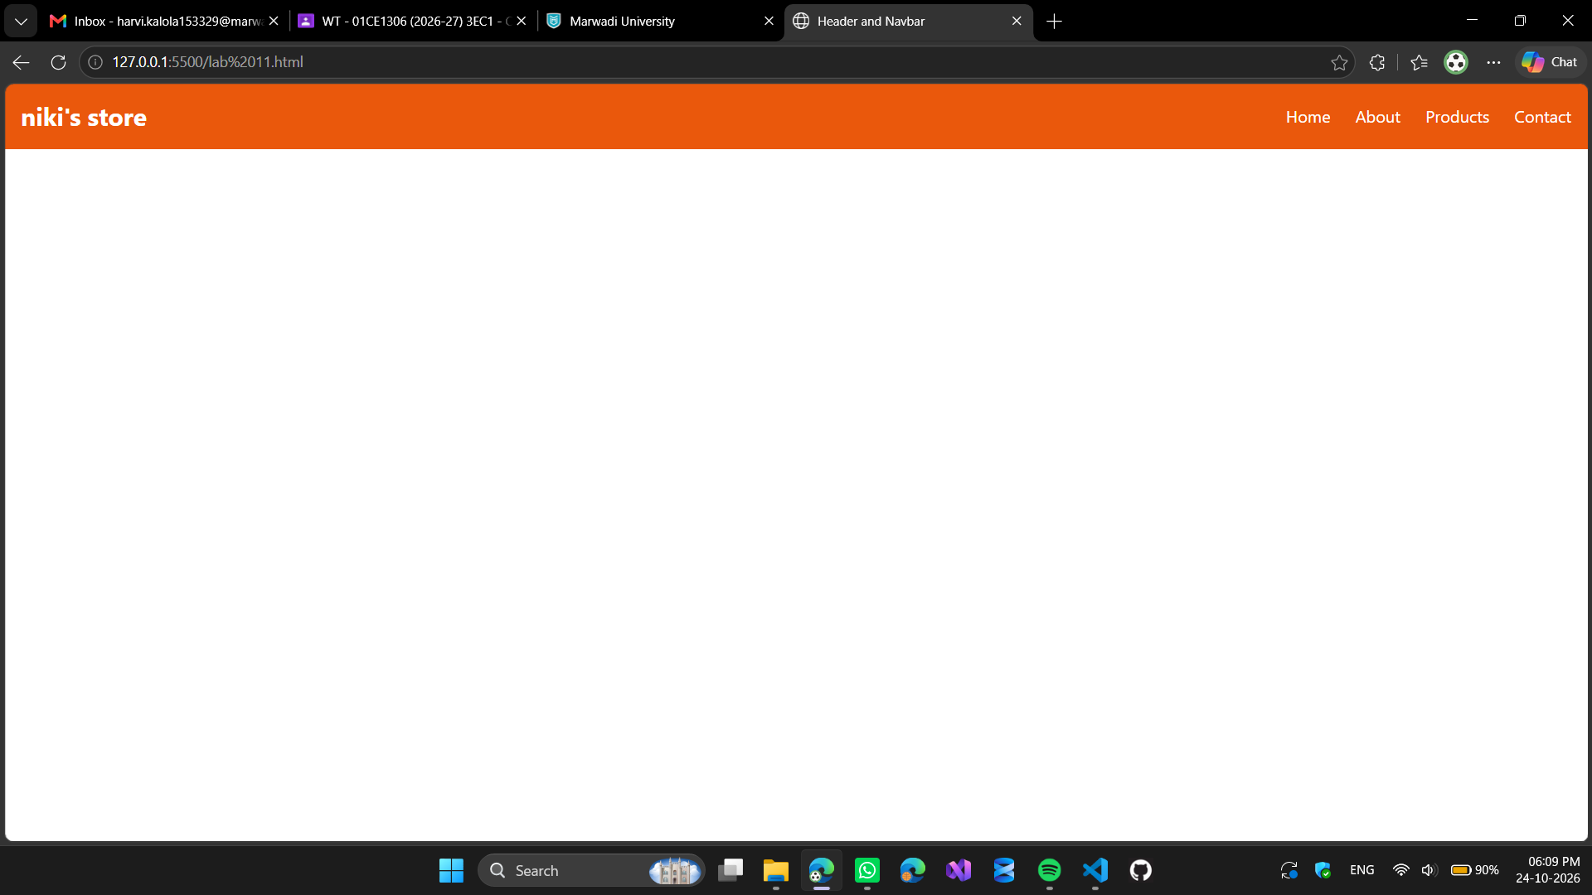

Code Snippet:

<!DOCTYPE html>
<html>
<head>
<title>Header and Navbar</title>
<script src="https://cdn.tailwindcss.com"></script>
</head>

<body>

<!-- Header -->
<header class="bg-orange-600 text-white p-4">

<div class="flex justify-between items-center">

<!-- Logo -->
<h1 class="text-2xl font-bold">niki's store</h1>

<!-- Navigation -->
<nav class="flex gap-6">

<a href="#" class="hover:text-purple-800">Home</a>

<a href="#" class="hover:text-purple-800">About</a>

<!-- Dropdown -->
<div class="relative group">

<button class="hover:text-purple-800">
Products
</button>

<div class="hidden group-hover:block absolute bg-white text-black p-2 w-32">

<a href="#" class="block p-2 hover:bg-gray-200">
Laptop
</a>

<a href="#" class="block p-2 hover:bg-gray-200">
Mobile
</a>

<a href="#" class="block p-2 hover:bg-gray-200">
Shoes
</a>

</div>
</div>

<a href="#" class="hover:text-purple-800">Contact</a>

</nav>

</div>

</header>

</body>
</html>

